Telfar currently has a customization done on some saved searches that allow them to print what they call Line Sheets.

The two referenced saved searches are:

* Color Matrix Linesheet: <https://6922326.app.netsuite.com/app/common/search/searchresults.nl?searchid=401&whence=>
* Size Matrix Linesheet: <https://6922326.app.netsuite.com/app/common/search/searchresults.nl?searchid=410&whence=>

When they click the Printer icon NetSuite will pop up a screen for them to select a template to use for printing.



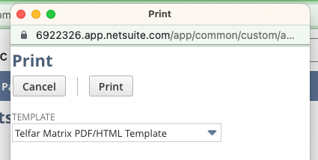

I believe this script is used to help generate the Linesheet: <https://6922326.app.netsuite.com/app/common/scripting/script.nl?id=660>

And this script: <https://6922326.app.netsuite.com/app/common/scripting/script.nl?id=661>

What Telfar would like to see if we can do is:  
“We were curious if there was a way we could adjust our linesheet formats in NS so that we are able to select the number of items/page?

Right now it is static @ 3 items per page. However sometimes a more condensed linesheet (for instance 6 items/pg) or even more spread out version (1 item/pg) would be good. Maybe there is a way to add a drop down that controls item info scale? Or a way to make multiple versions with different layouts?”

Can you see if we can modify the script to expose an additional parameter on that popup screen OR create additional templates that would determine how many per page? Ideally, we can have the additional parameter.